## Customer Requirements Speciﬁcation

**SAG_ML_actRecog ــــــــــــــــــــــــــــــــــــــــــــــــــــــــــــــــــــــــــــــــــــــــــــــــــــــــــــــــــــــــــــــــــــــــــــــــــــــــــــــــــــــــــــــــــــــــــــــــــــــــــــــــــــــــــــــــــــــــــــــ**

**Table of Contents**

Document Status 1

Document History 1

Reference Document 2

Project Description 2

# Document Status:

|  |  |
| --- | --- |
| **Name** | PO_ٍSAG_CRS_ML_actRecog |
| **Version** | V1.1 |
| **Status** | proposed |
| **Author** | SAM |
| **Date** | [8-11-2022] |
| **Team Approval** | Muhammad Essam |
| **Mentor Approval** |  |
| **Final Approval** |  |

# Document History:

|  |  |  |  |
| --- | --- | --- | --- |
| **Version** | **Author** | **Date** | **Change** |
| 1.0 | SAM | [8-11-2022] | * Initial Creation * Add CRS Requirements |
| 1.1 | SAM | [15-11-2022] | * Edit name of document * Edit the change of the previous history * Edit Project definition description * Edit key elements * Edit system context * Edit CRS requirements |

# Reference Document:

|  |  |  |  |
| --- | --- | --- | --- |
| **Ref.number** | **Doc.Name** | **Version** | **Status** |
| 1 | PO_SAG_CR_ML_actRecog | V1.0 | Released |

# Project Description:

## Definition:

The feature of activity recognition shall describe the activities around the blind

## Features:

* Activity recognition

## Key Elements:

* The activity recognition model shall describe the different activities and actions around the user.



## **image captioning**

## System Context:

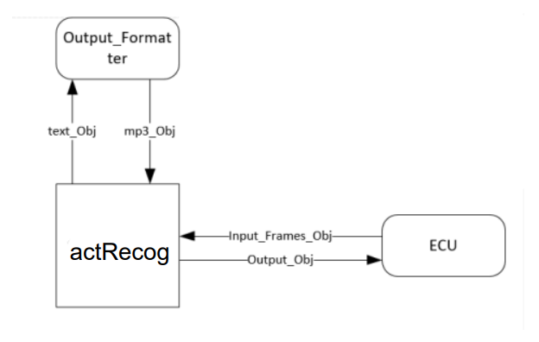

## CRS Requirements:

|  |  |  |  |
| --- | --- | --- | --- |
| **Req_ID** | PO_SAG_CR_ML_003-V1.1 | **Covers** | PO_ٍSAG_CRS_ML_actRecog_001_v1.1 |
| **Description** | A resize algorithm shall resize the input frames to suit the model. | | |

|  |  |  |  |
| --- | --- | --- | --- |
| **Req_ID** | PO_SAG_CR_ML_003-V1.1 | **Covers** | PO_ٍSAG_CRS_ML_actRecog_002_v1.1 |
| **Description** | The CNN model shall process the frames to extract distinguished features | | |

|  |  |  |  |
| --- | --- | --- | --- |
| **Req_ID** | PO_SAG_CR_ML_003-V1.1 | **Covers** | PO_ٍSAG_CRS_ML_actRecog_003_v1.1 |
| **Description** | The RNN model shall understand the context | | |

|  |  |  |  |
| --- | --- | --- | --- |
| **Req_ID** | PO_SAG_CR_ML_003-V1.1 | **Covers** | PO_ٍSAG_CRS_ML_actRecog_004_v1.1 |
| **Description** | The RNN model shall output the expressive description in the form of text | | |

|  |  |  |  |
| --- | --- | --- | --- |
| **Req_ID** | PO_SAG_CR_ML_003-V1.1 | **Covers** | PO_ٍSAG_CRS_ML_actRecog_005_v1.1 |
| **Description** | The RNN model shall understand the context | | |

|  |  |  |  |
| --- | --- | --- | --- |
| **Req_ID** | PO_SAG_CR_ML_003-V1.1 | **Covers** | PO_ٍSAG_CRS_ML_actRecog_006_v1.1 |
| **Description** | Output formatter shall format the text output to mp3 format | | |

|  |  |  |  |
| --- | --- | --- | --- |
| **Req_ID** | PO_SAG_CR_ML_003-V1.1 | **Covers** | PO_ٍSAG_CRS_ML_actRecog_007_v1.1 |
| **Description** | The model shall return the description to ECU | | |